**Lab – 3 (programming statement)**

1) Using input() function take one number from the user and using ternary operators check whether the number is even or odd .

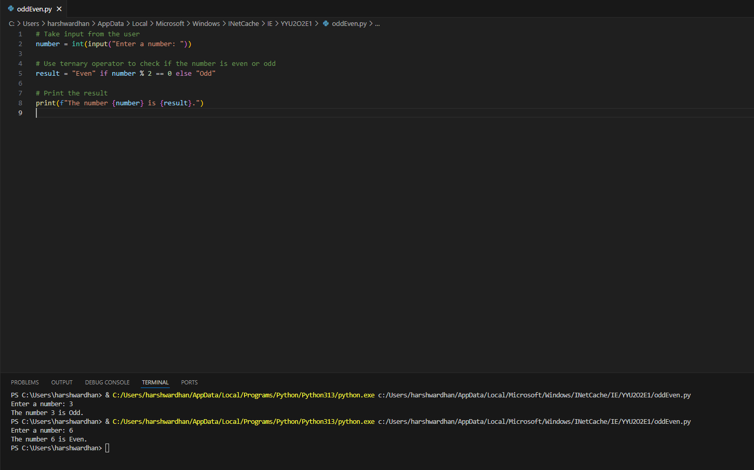

2) Using input function take two number and then swap the number .

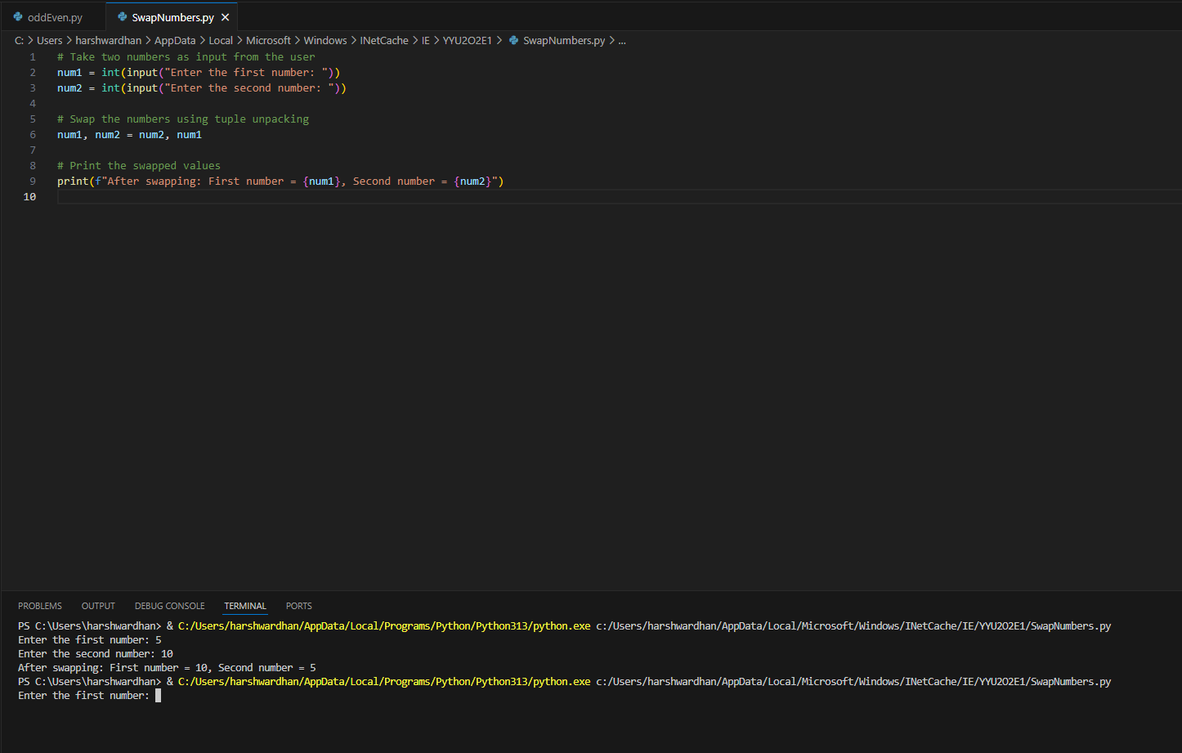

3) Write a Program to Convert Kilometers to Miles .

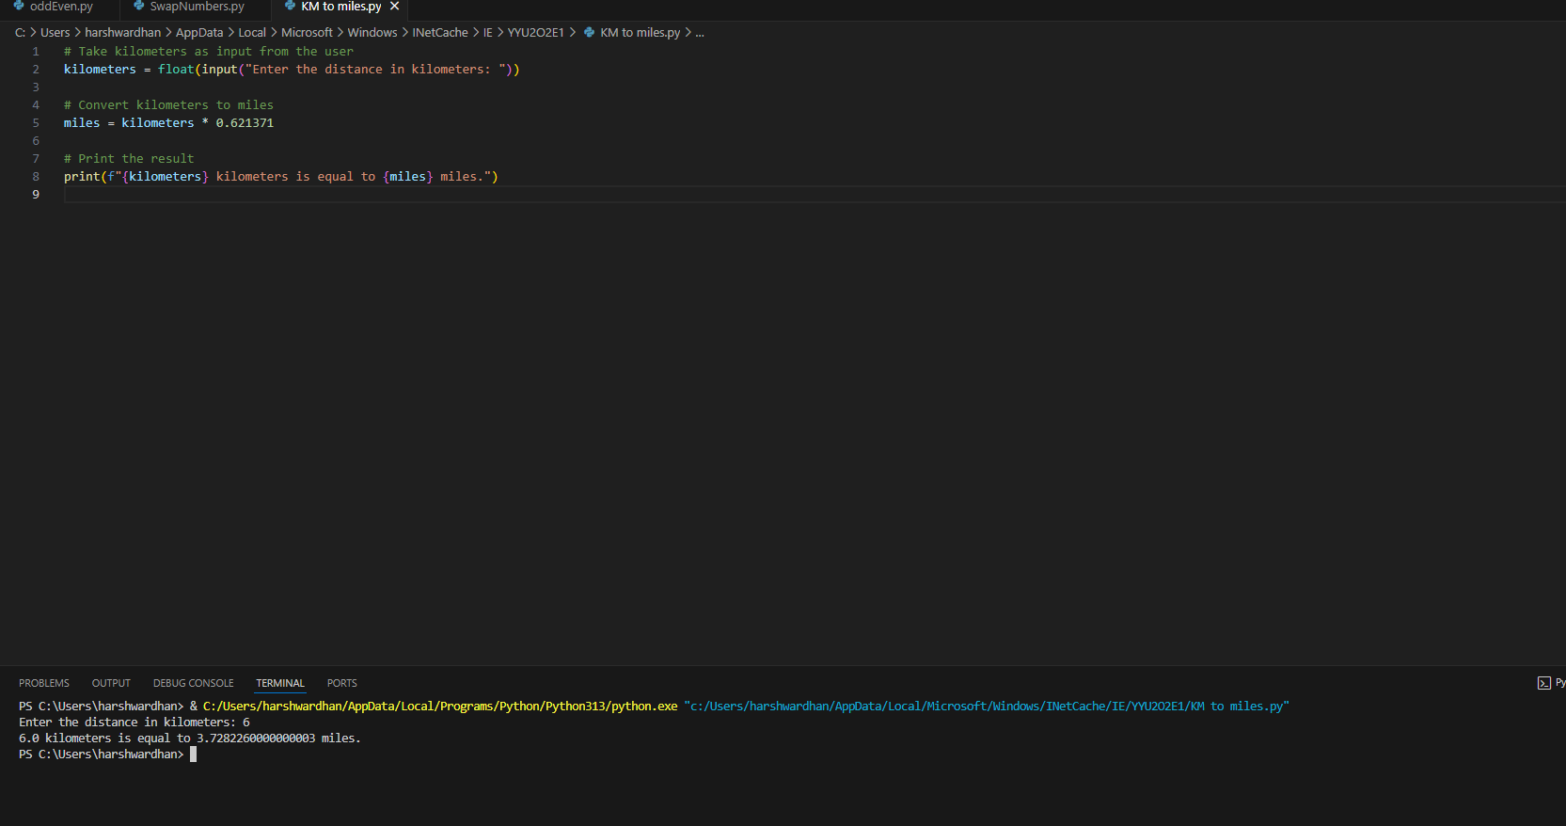

4) Find the Simple Interest on Rs. 200 for 5 years at 5% per year.

:- To calculate **Simple Interest (SI)**, we use the formula:

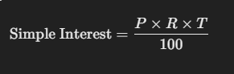

Where:

* PPP is the principal amount (Rs. 200),
* RRR is the rate of interest (5% per year),
* TTT is the time in years (5 years).

Now, let’s calculate the Simple Interest:

**Given:**

* Principal (P) = Rs. 200
* Rate (R) = 5% per year
* Time (T) = 5 years

**Calculation:**

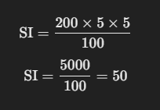

Thus, the Simple Interest is **Rs. 50**.

